20161116
# Installation process OS on Dell server is differ, than same thing on HP server.
#
# To install rhel 6 correctly I’ve read follow document: “Unattended Installation of Red Hat Enterprise Linux 7 Operating System on Dell PowerEdge Servers Using iDRAC With Lifecycle Controller.pdf”
# As I understood, there is no way to use unattended installation via ks.cfg and via Lifecycle Controller - because only for rhel 7 available checkboks, that allow to use unattended installation.

# I had tried to install rhel 6.6 directly from iso image (without using Lifecycle Controller), but installator was not found hard drives. It because in installator was absent Dell’s raid controller drivers...

# To enter into “Lifecycle Controller” it needs to press “F10” button.
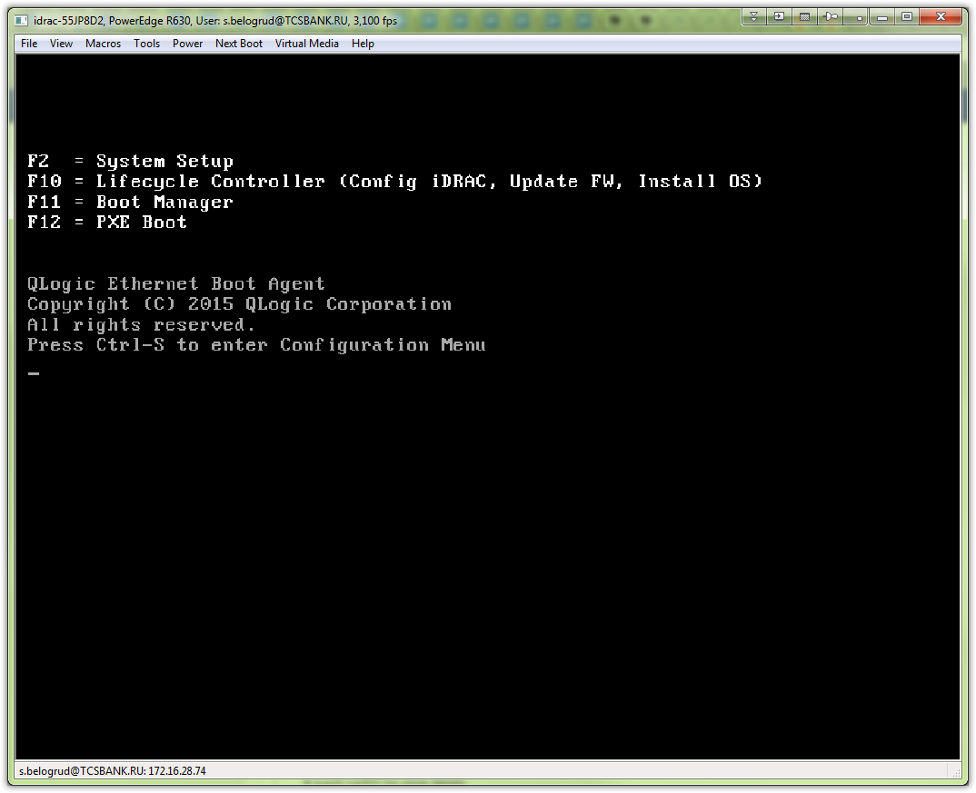

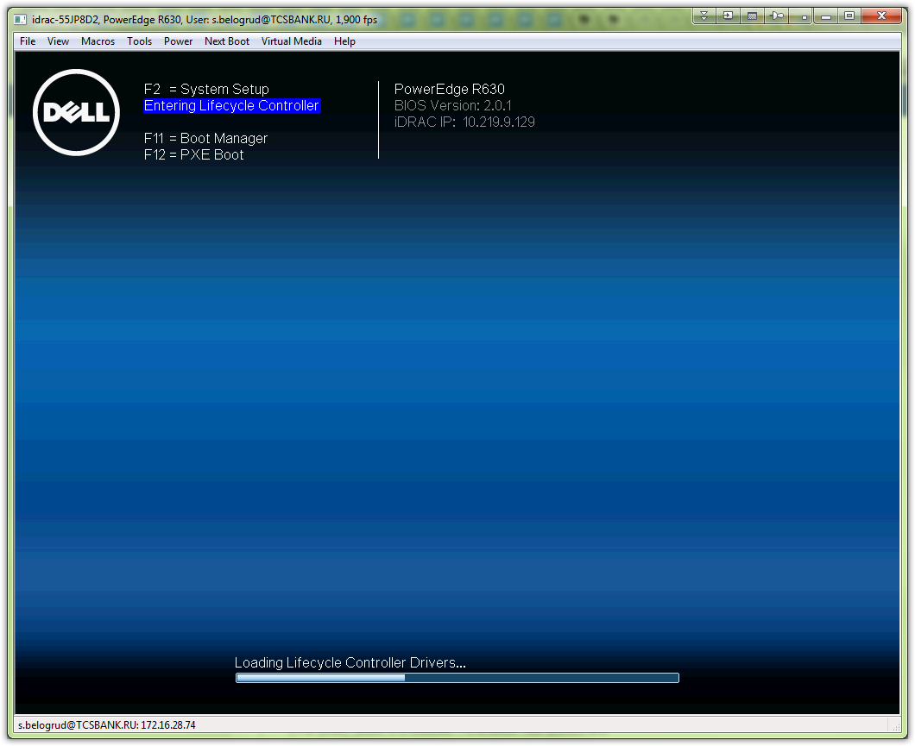

# Needs to check “OS Deployment”.
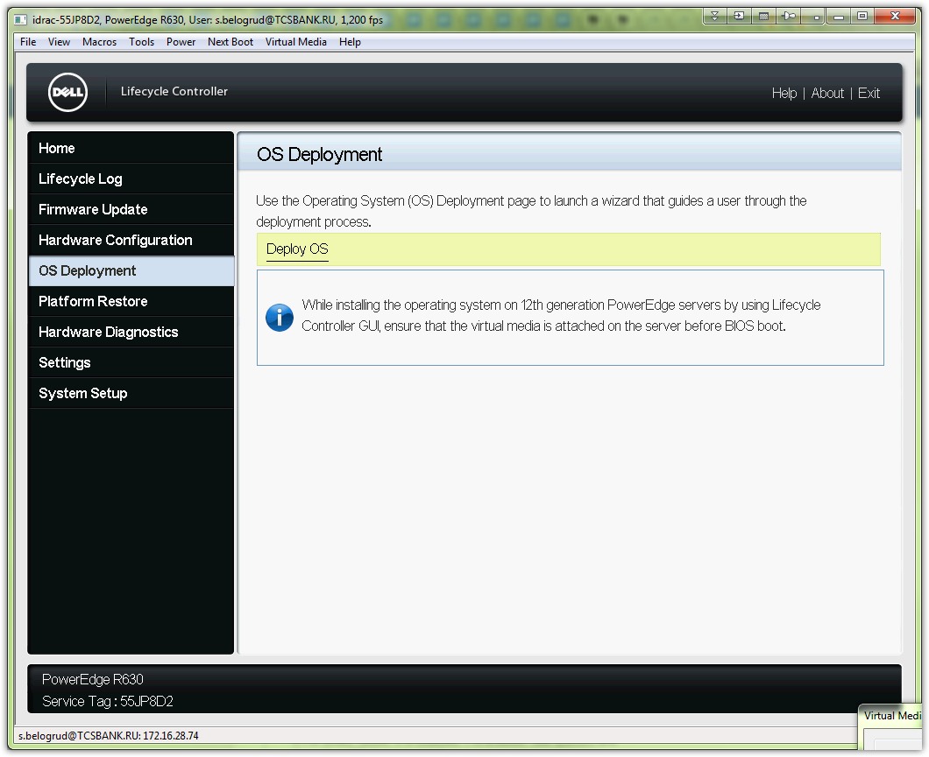

# Before continue it’s better to insert iso image of OS, that we planning to install.
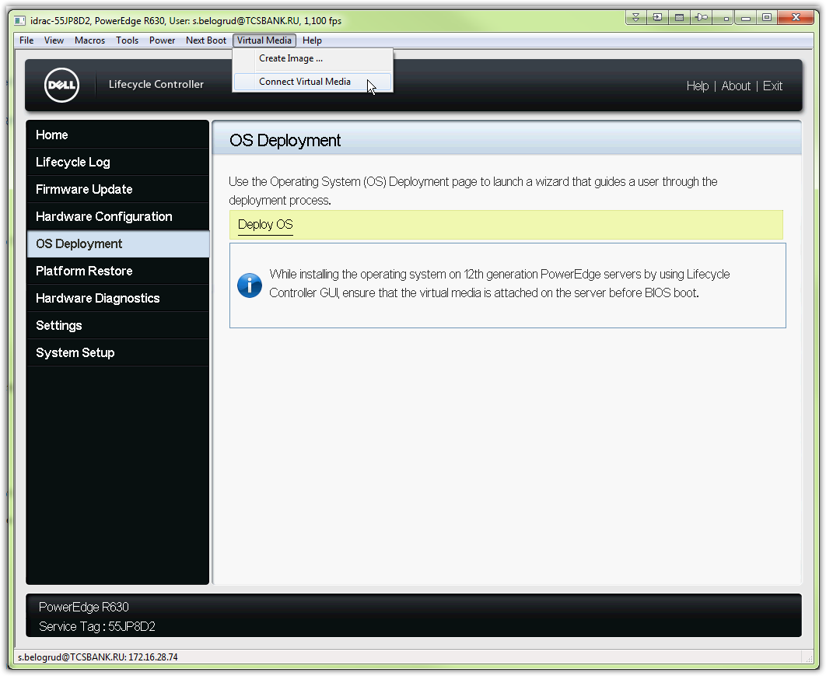
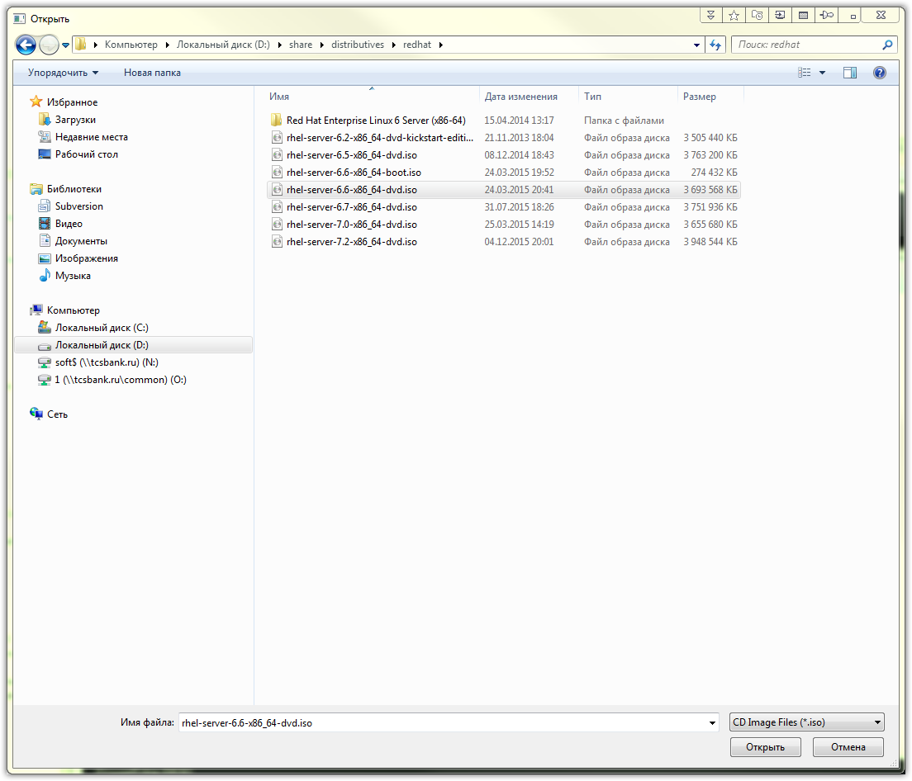

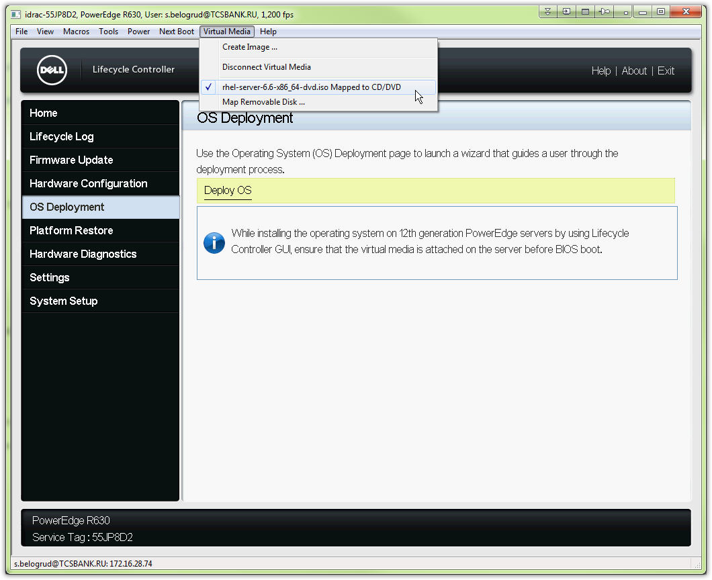

# The first of all - we should configure properly raid controller.
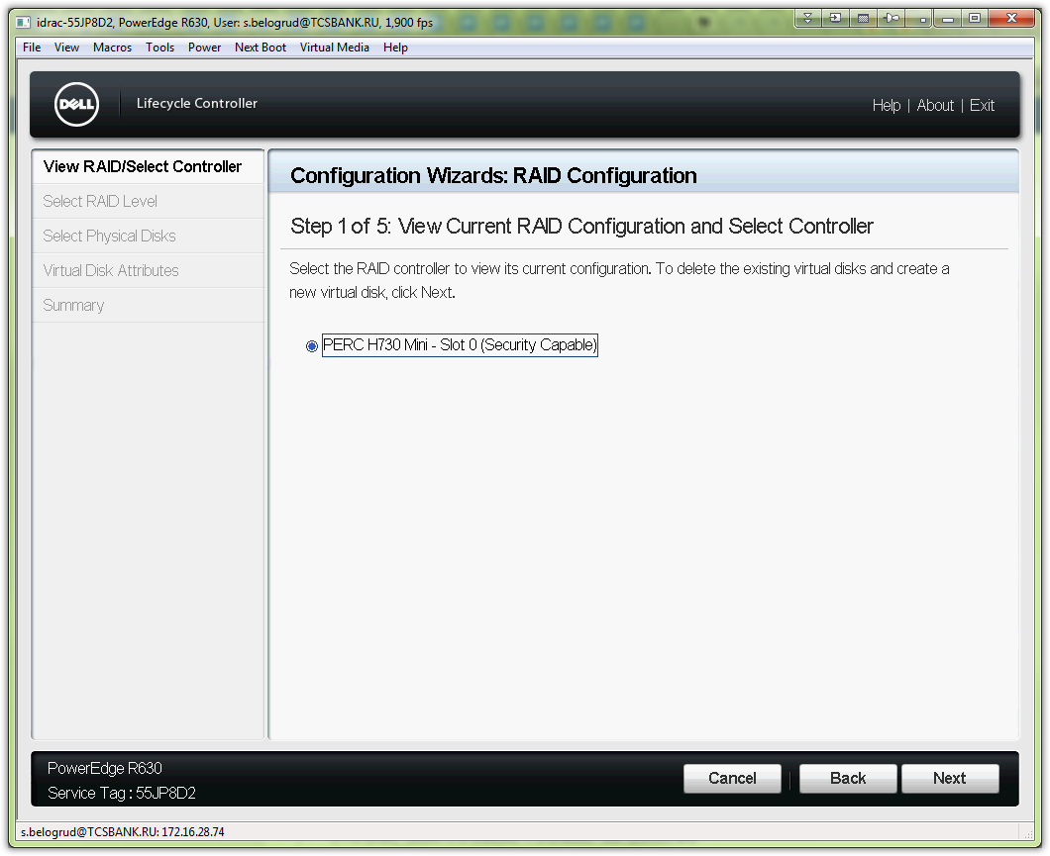

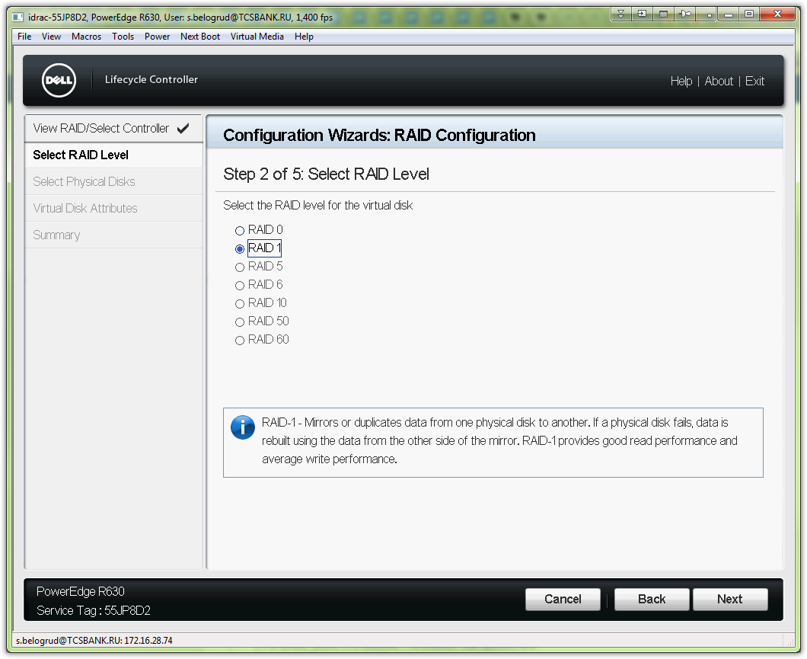

# Here were choosed hard drives, that pllanned to use.
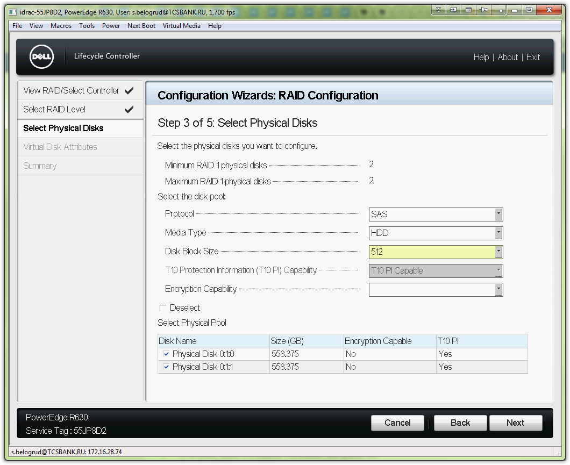

# I’m don’t know exactly what this field “Virtual Disk Name” means, but I’ve typed here “sda”.
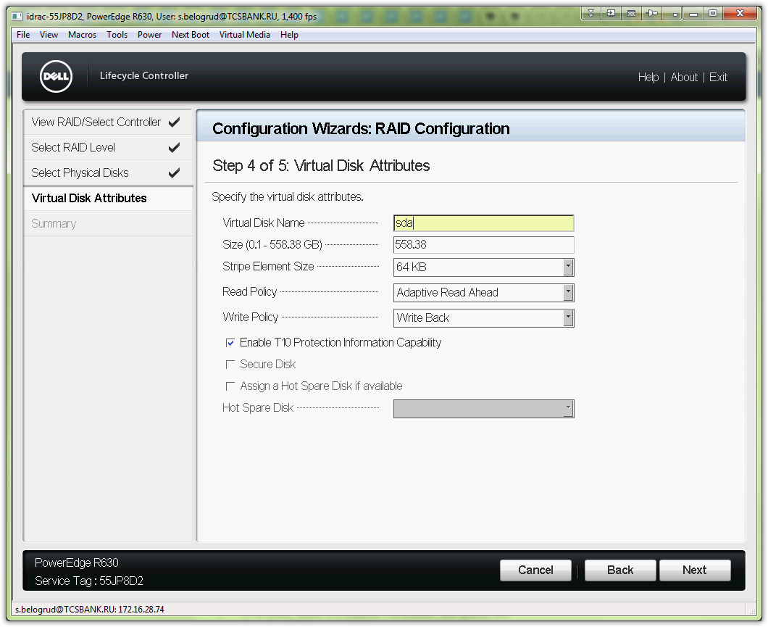

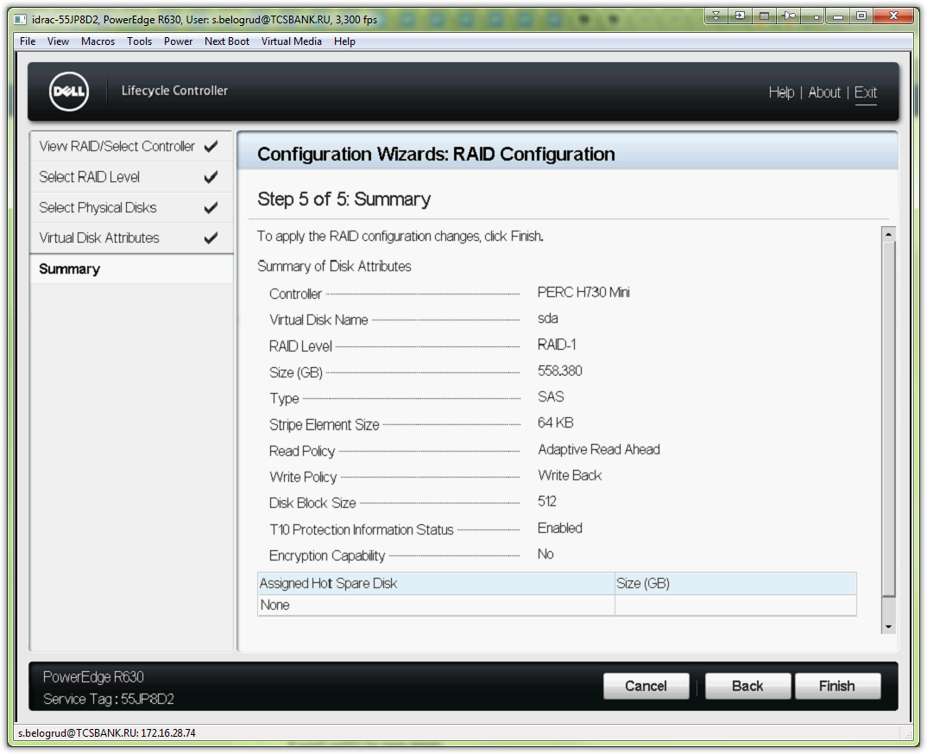
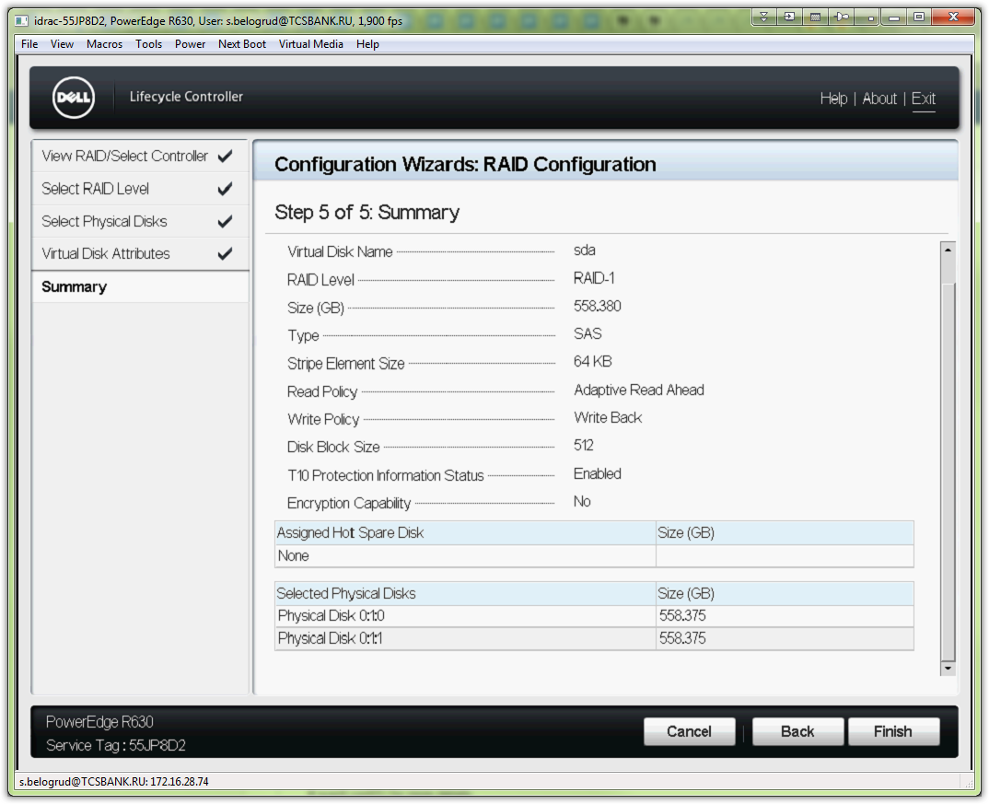

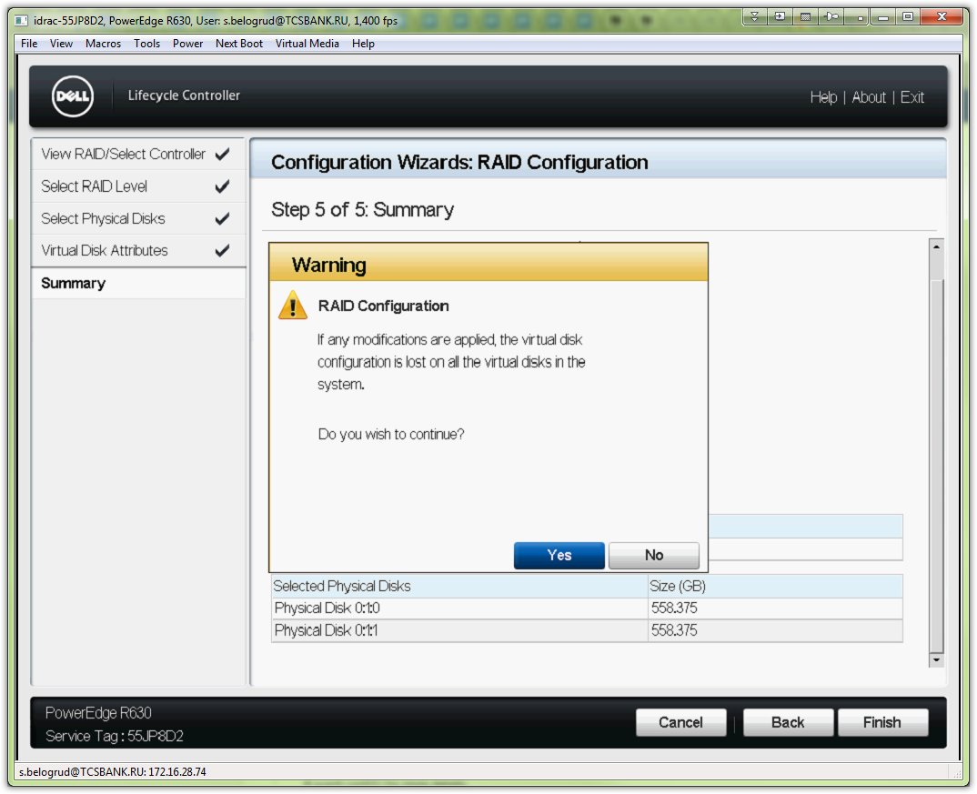

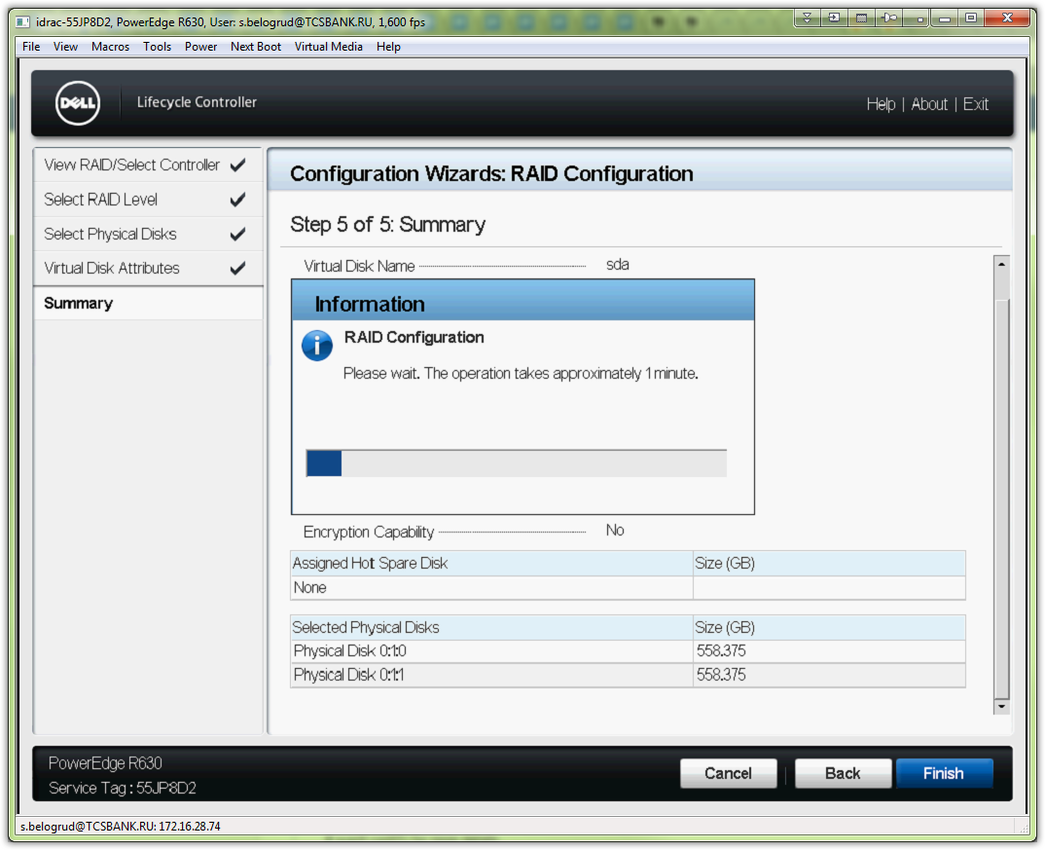

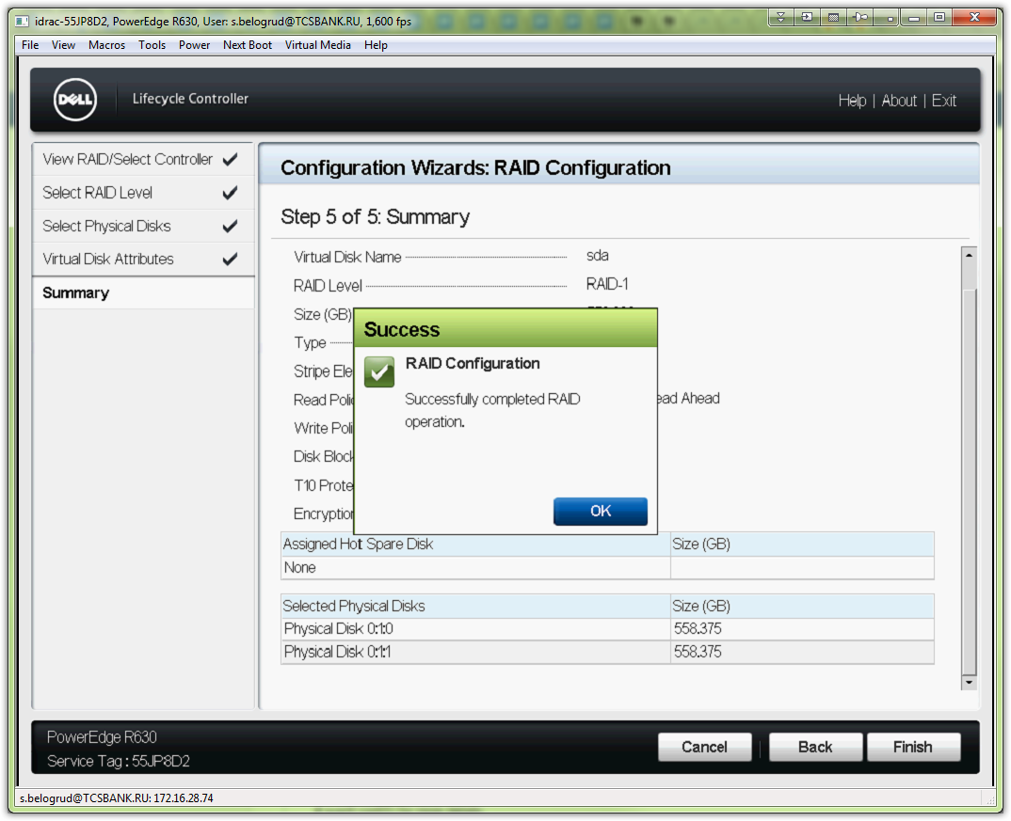

# Here we can see list of OSes, that could be installed via Lifecycle Controller.
# I wanted to install rhel 6.6 - it’s absent in this list. Wherefore I used to maximum closest version of OS - it was rhel 6.7.
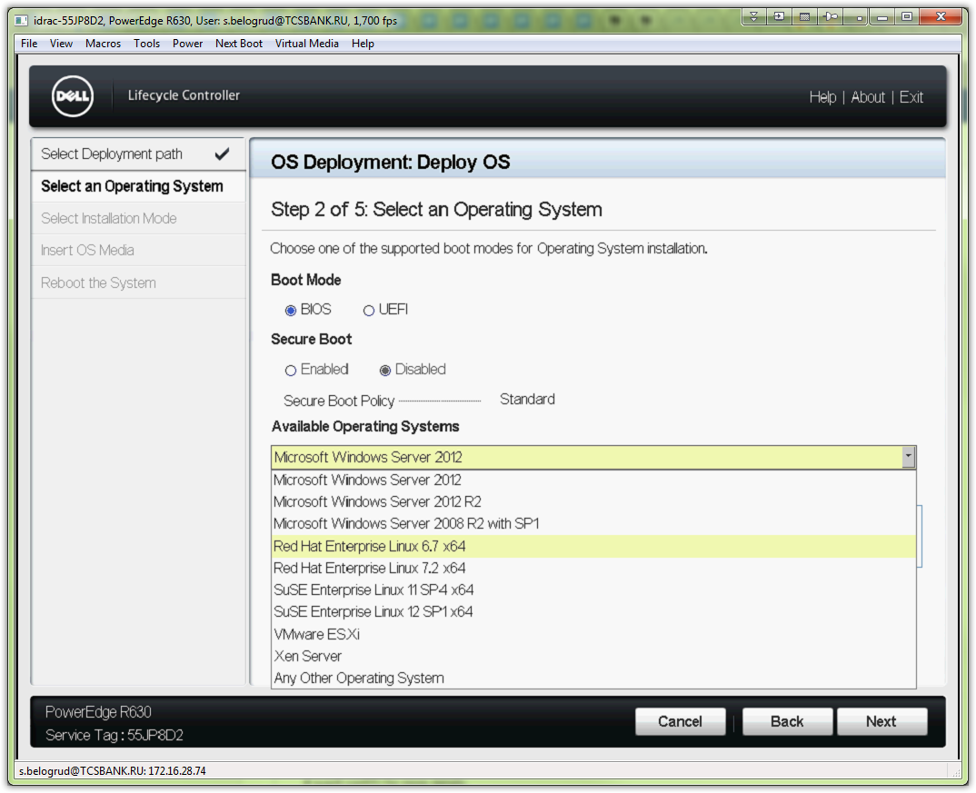

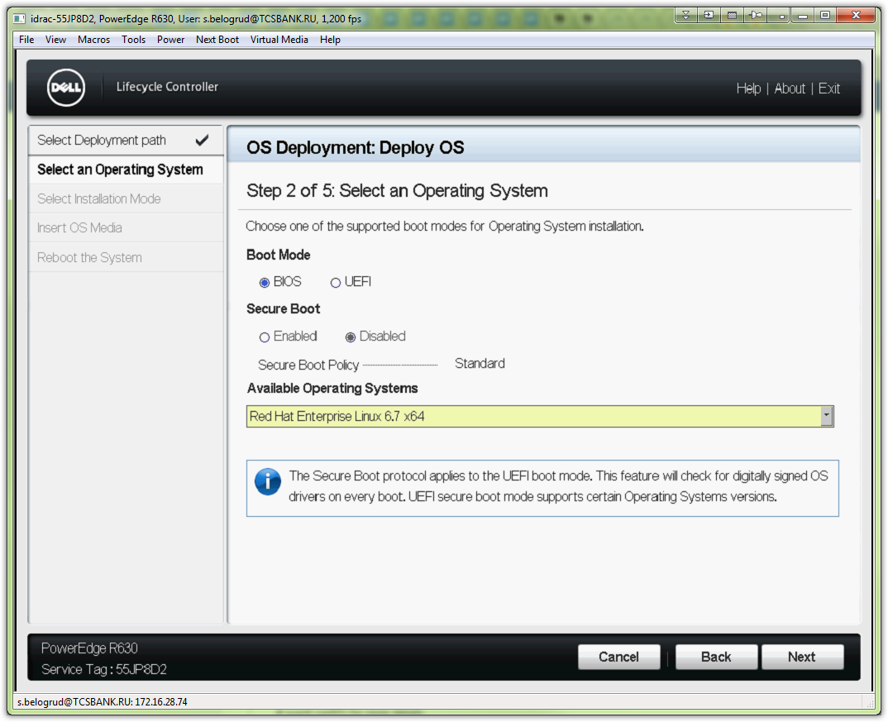

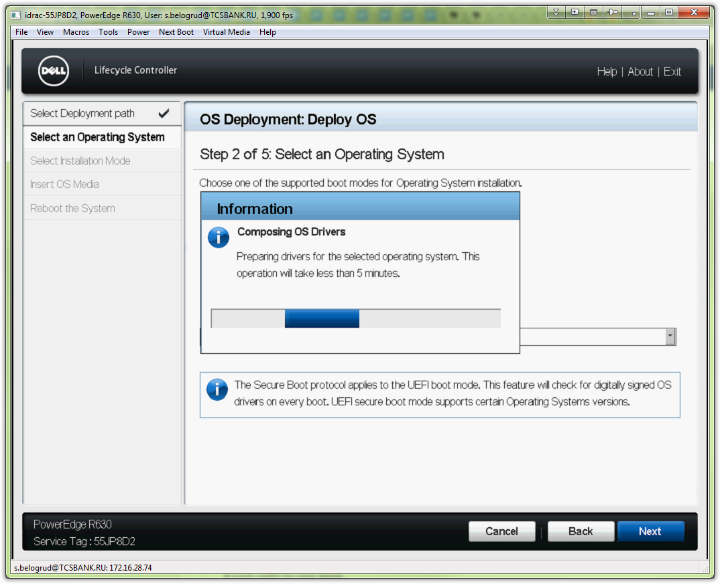

# In this step we can see that option of “Unattended Install” is unavailable for rhel 6 generation of OSes. That’s mean that we cannot use ks.cfg preconfigured file to install our OS...
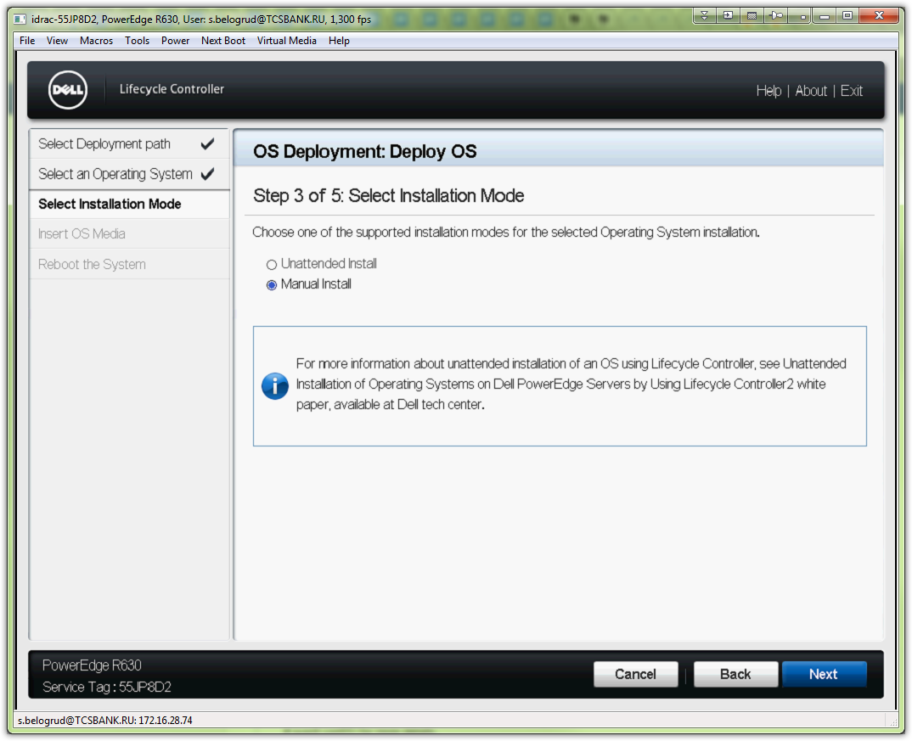

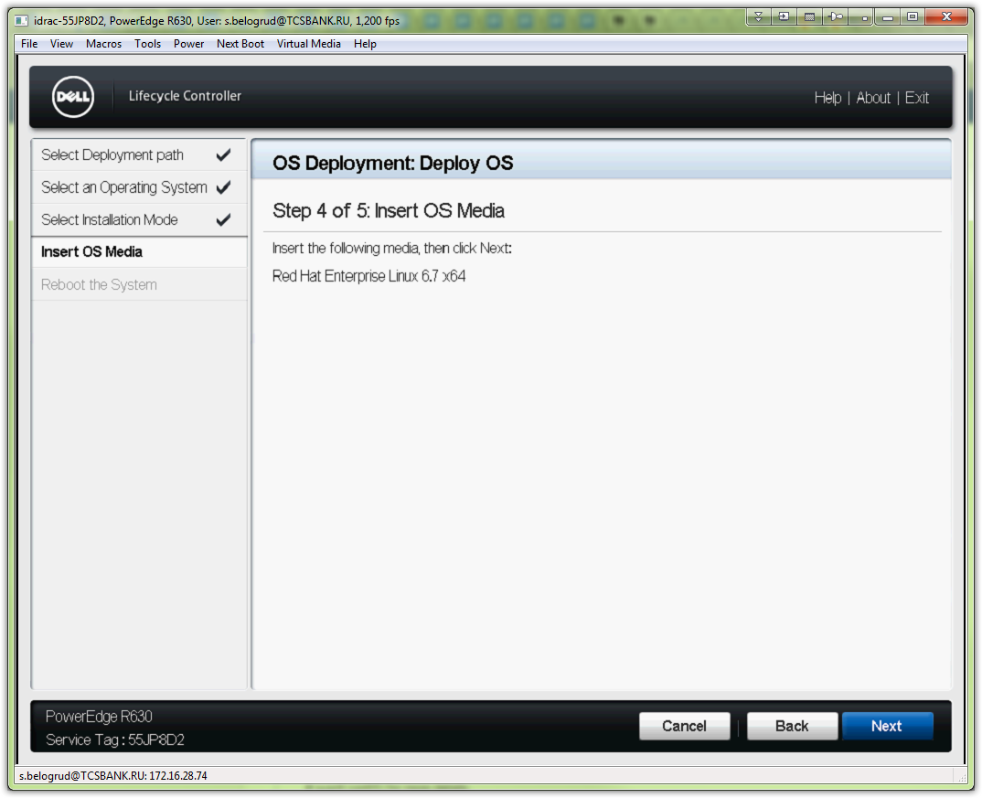

# This is warning, that our iso image of OS distributive is differ, than our previous choice (rhel 6.7).
# Anyway I choosed to use it.
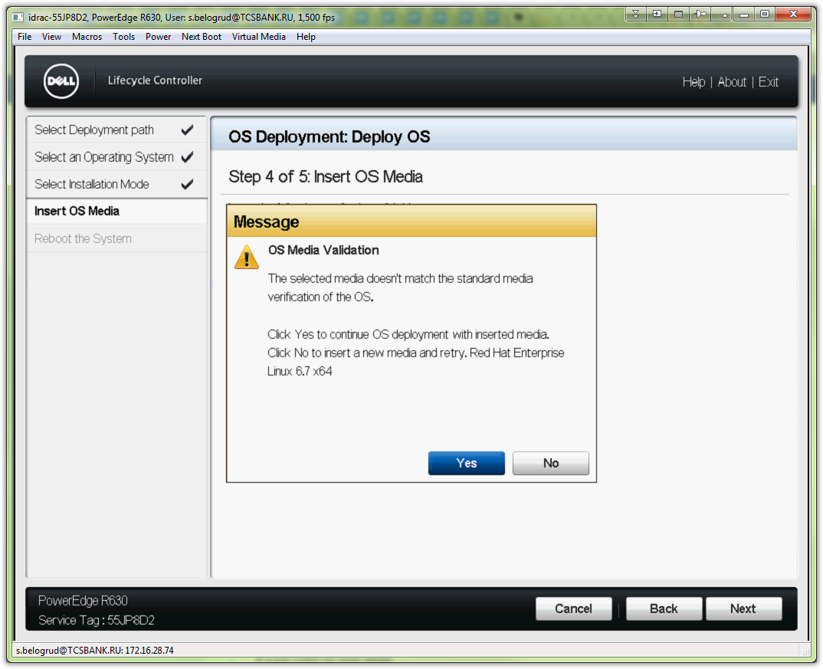

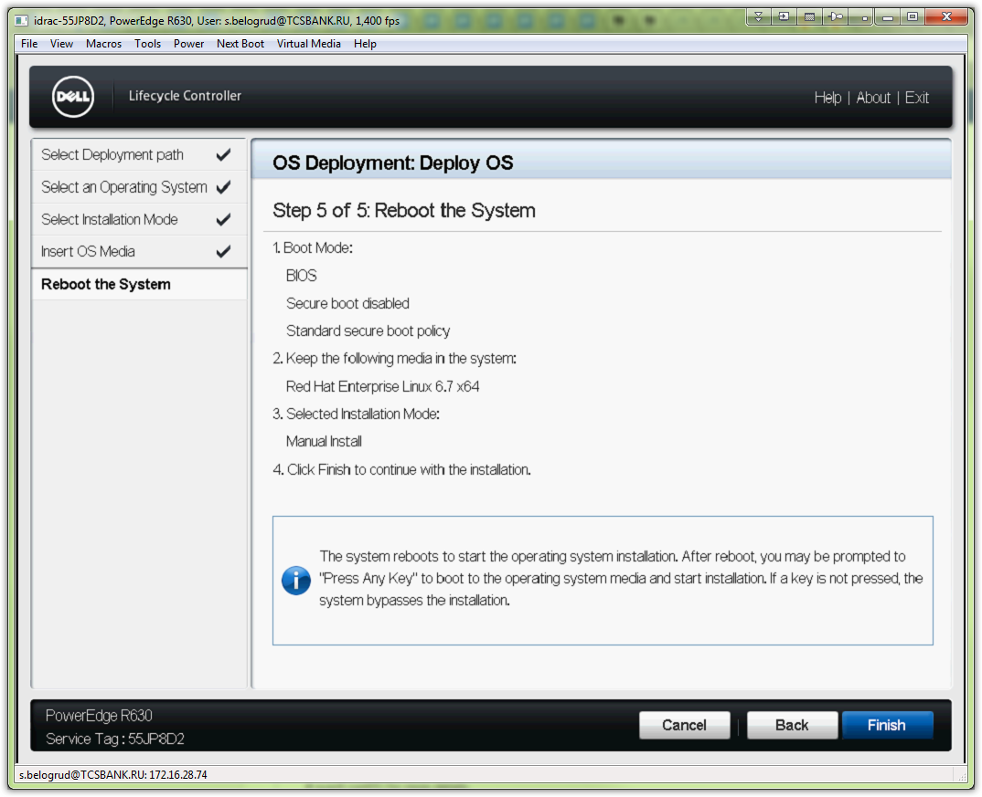

# After server was rebooted automatically, begin regular process of rhel 6 installation.
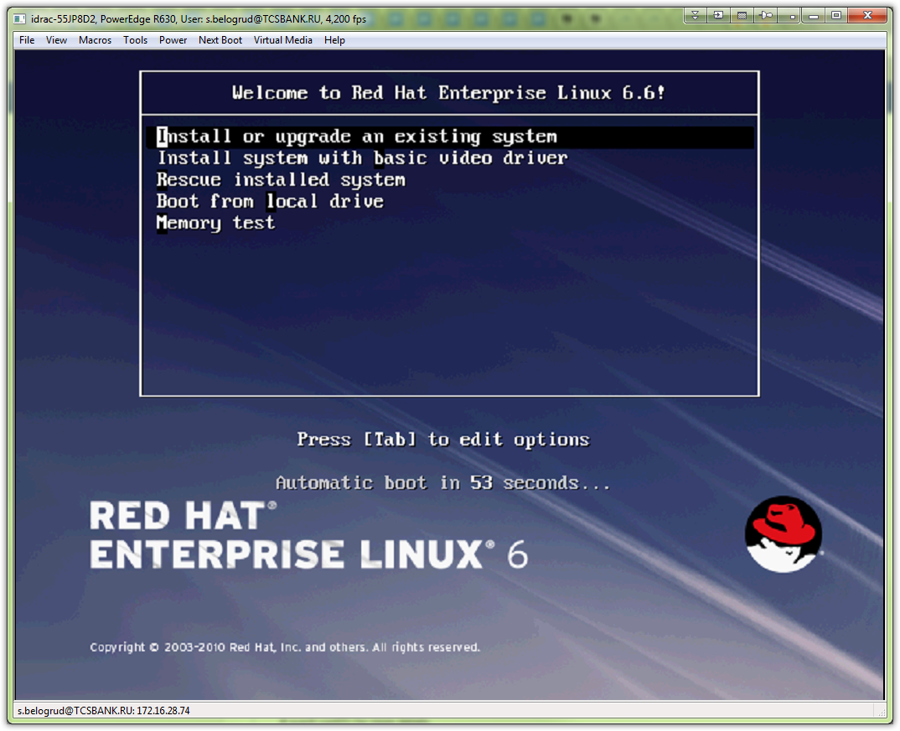

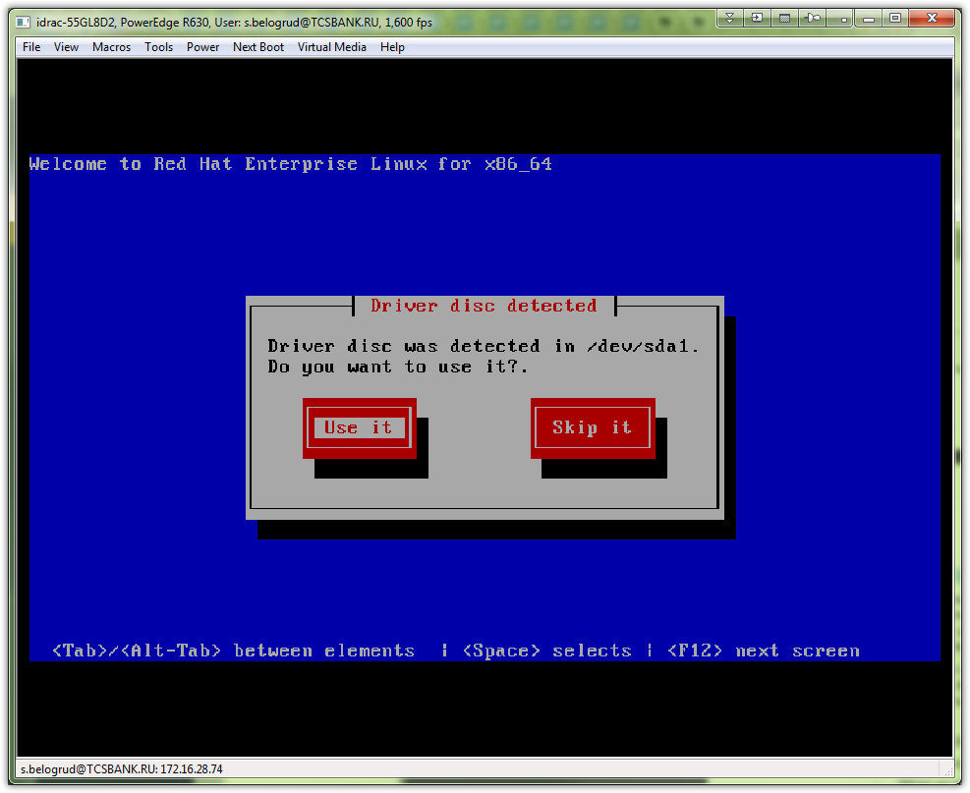

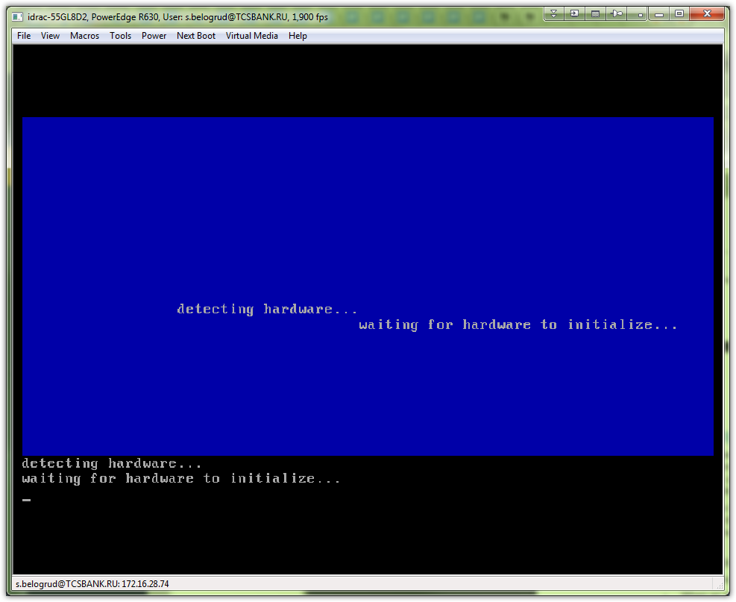

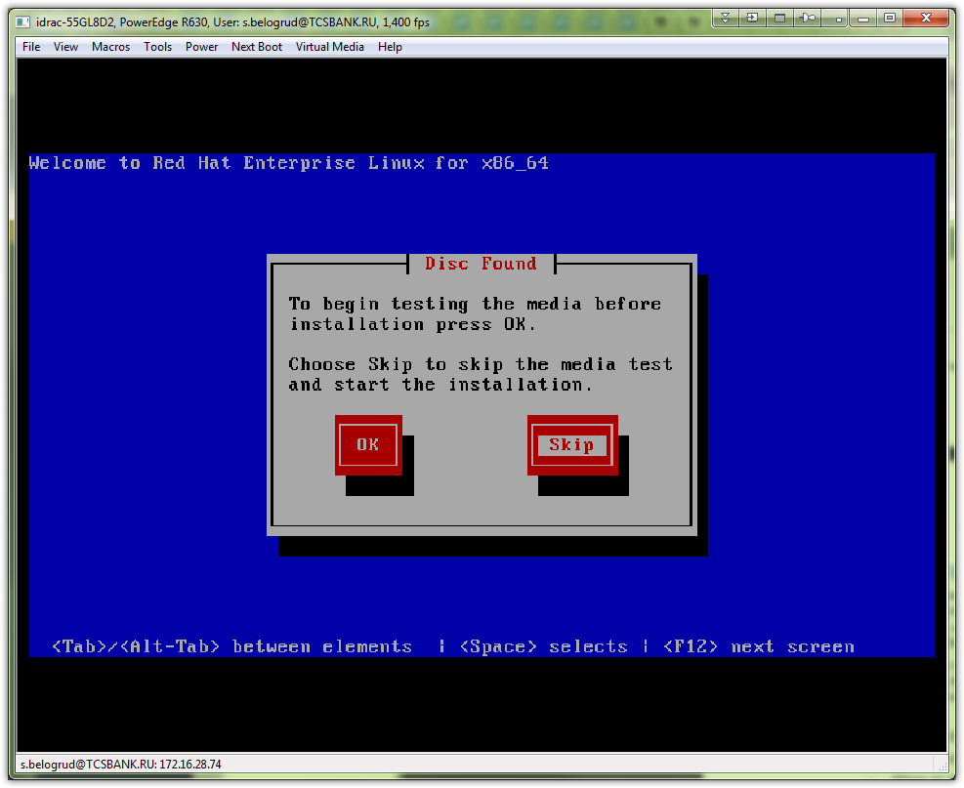

# Here we were wait for 1.5 mitutes until installation continue.
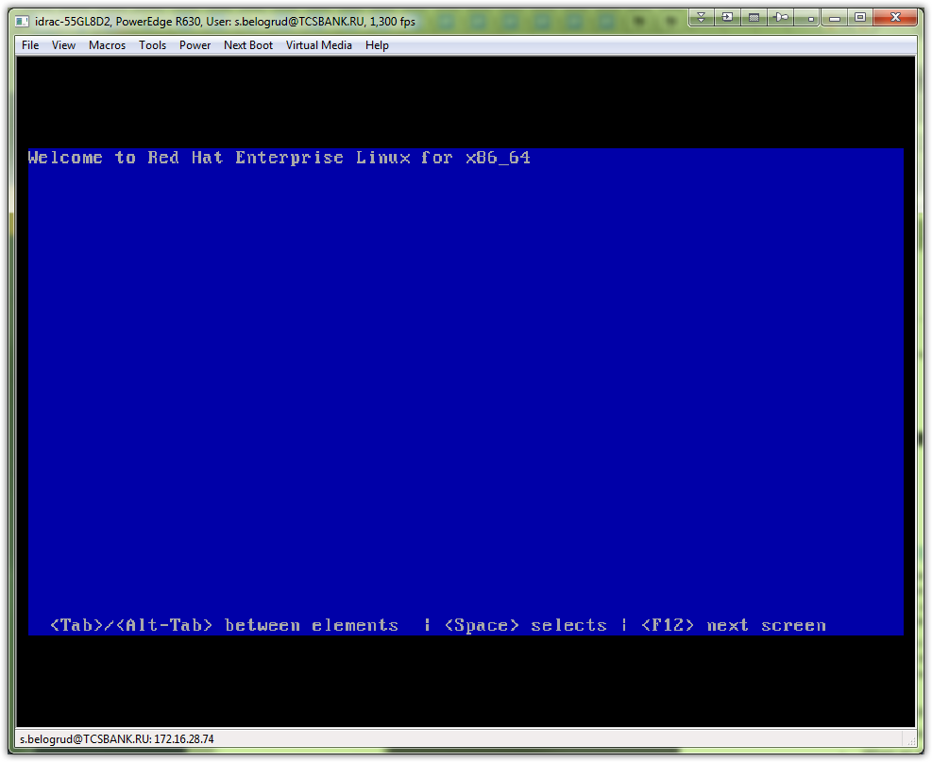

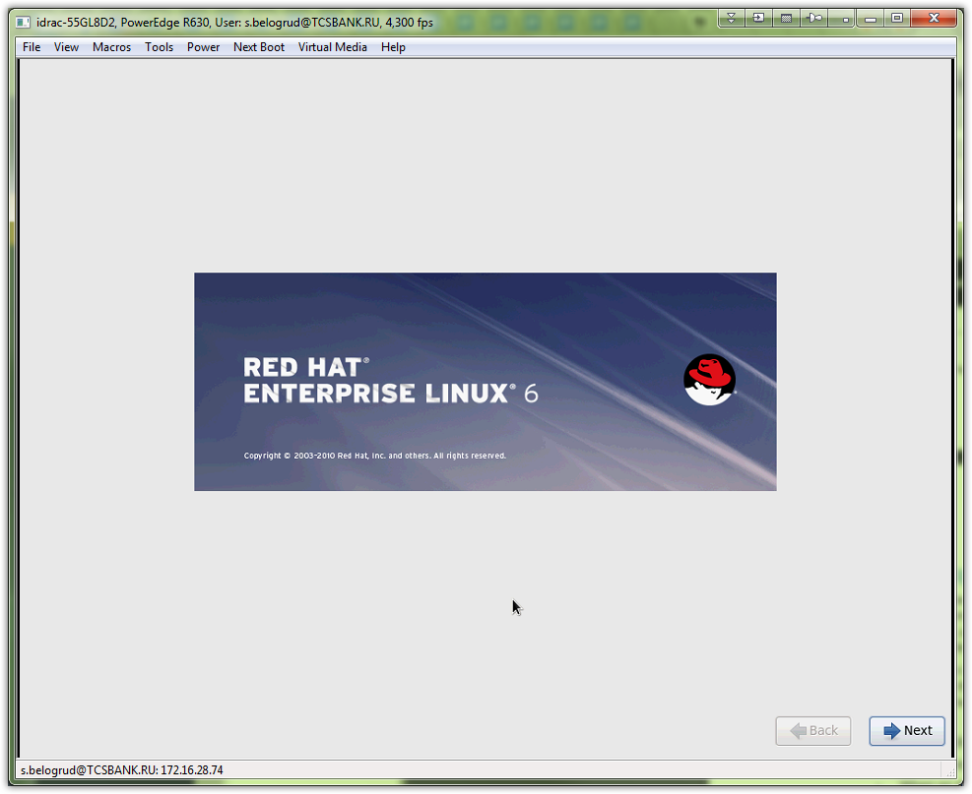

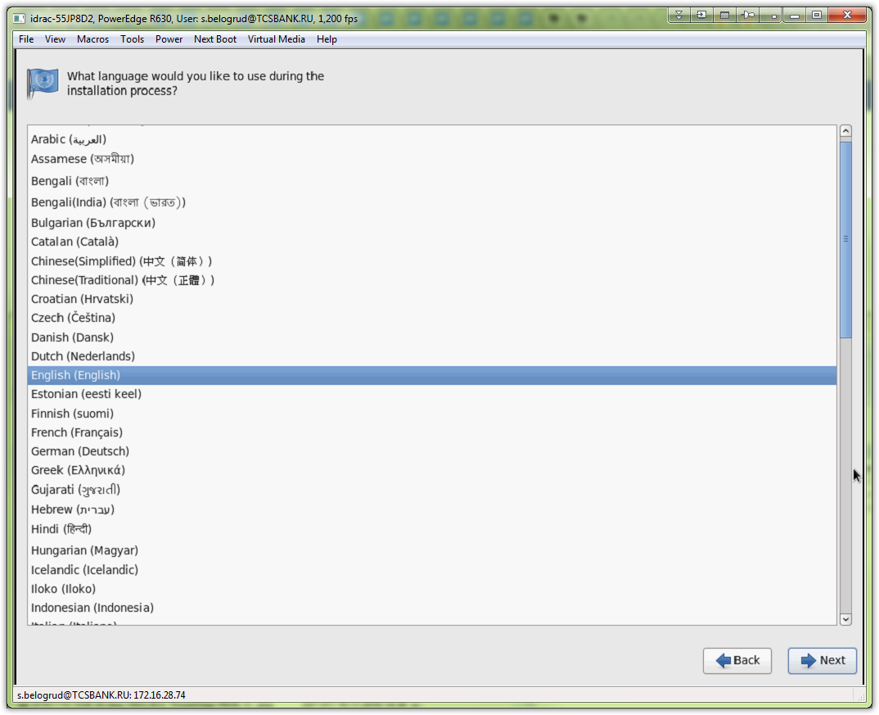

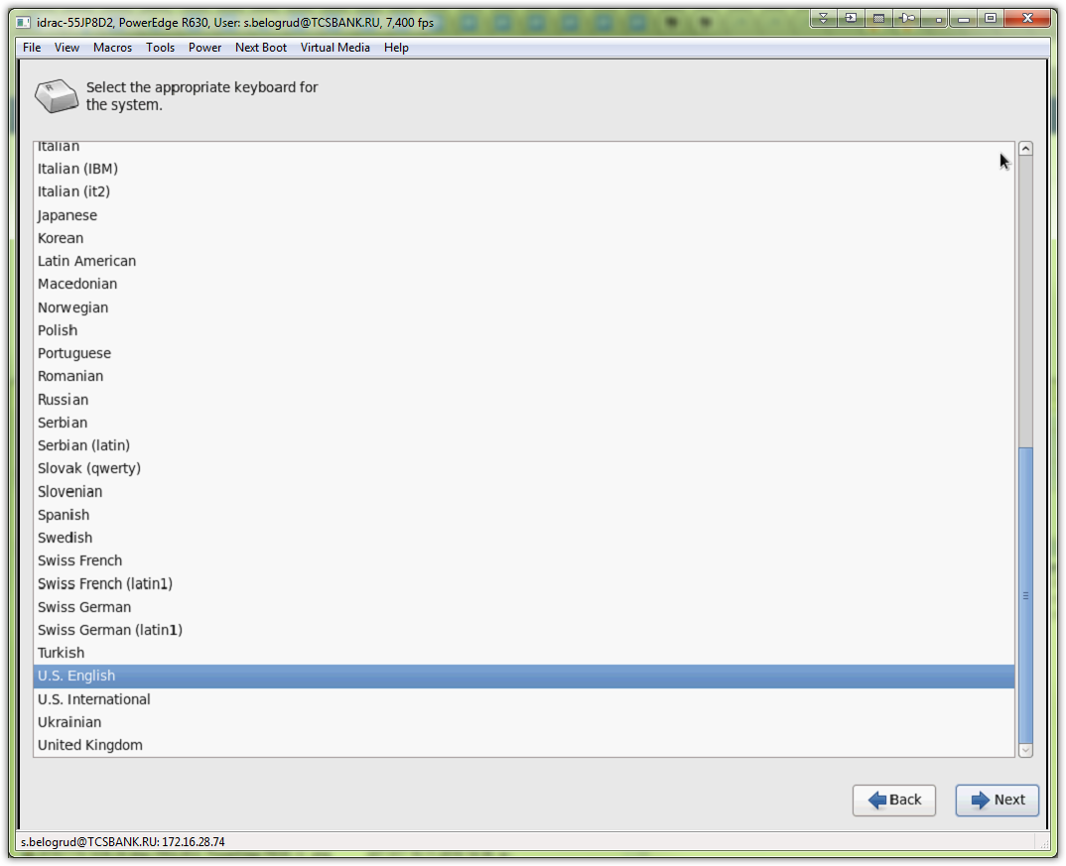

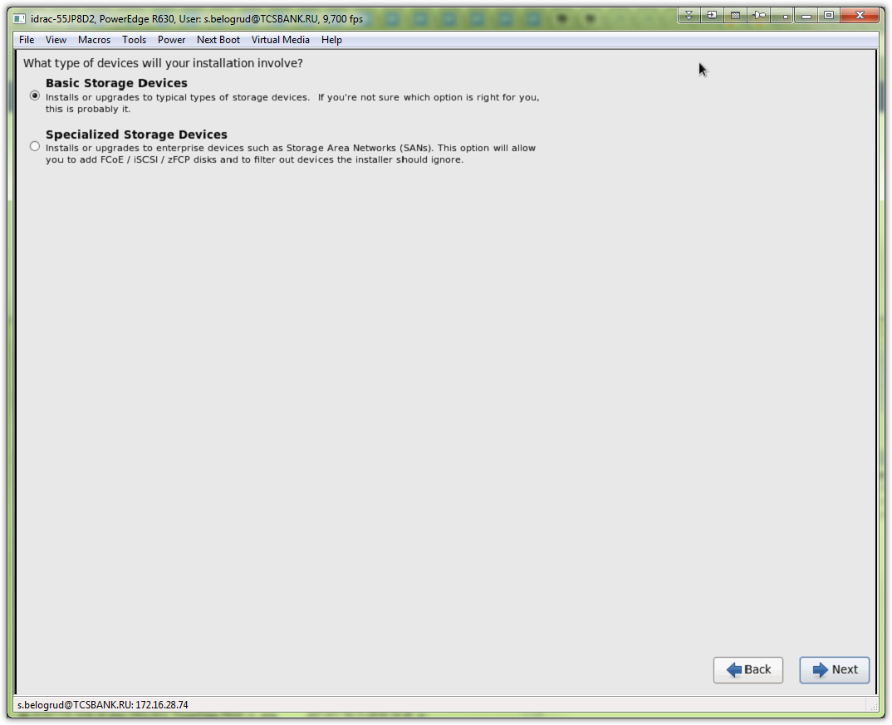

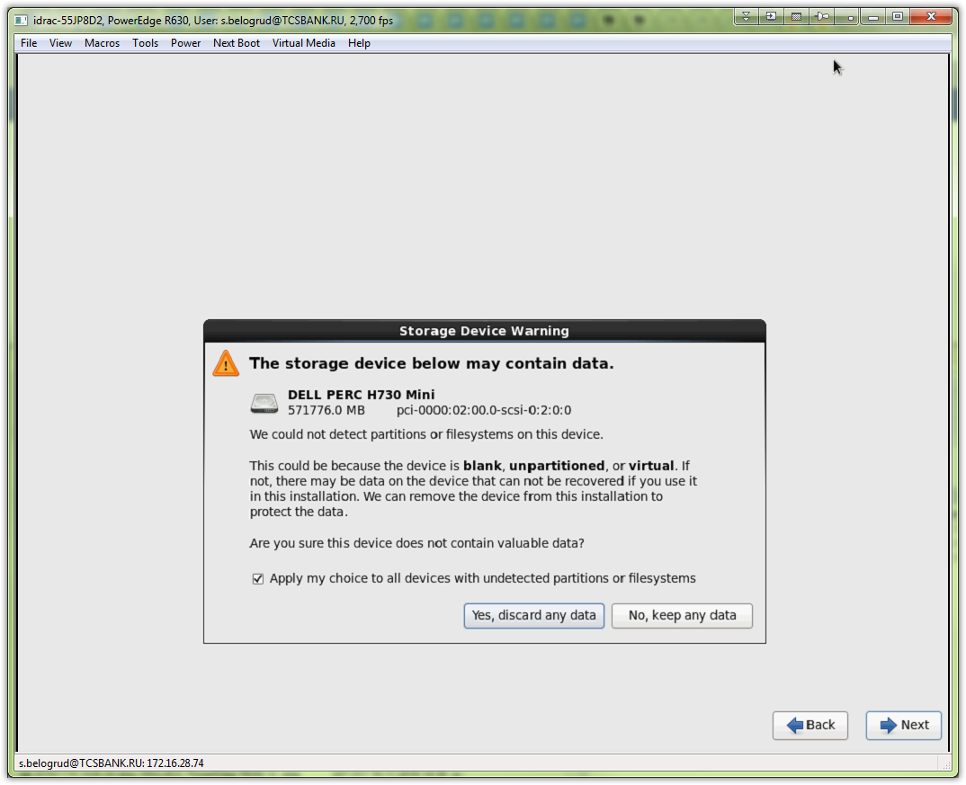

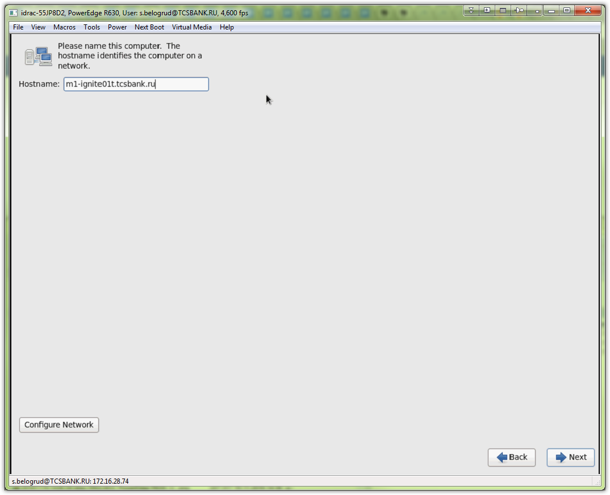

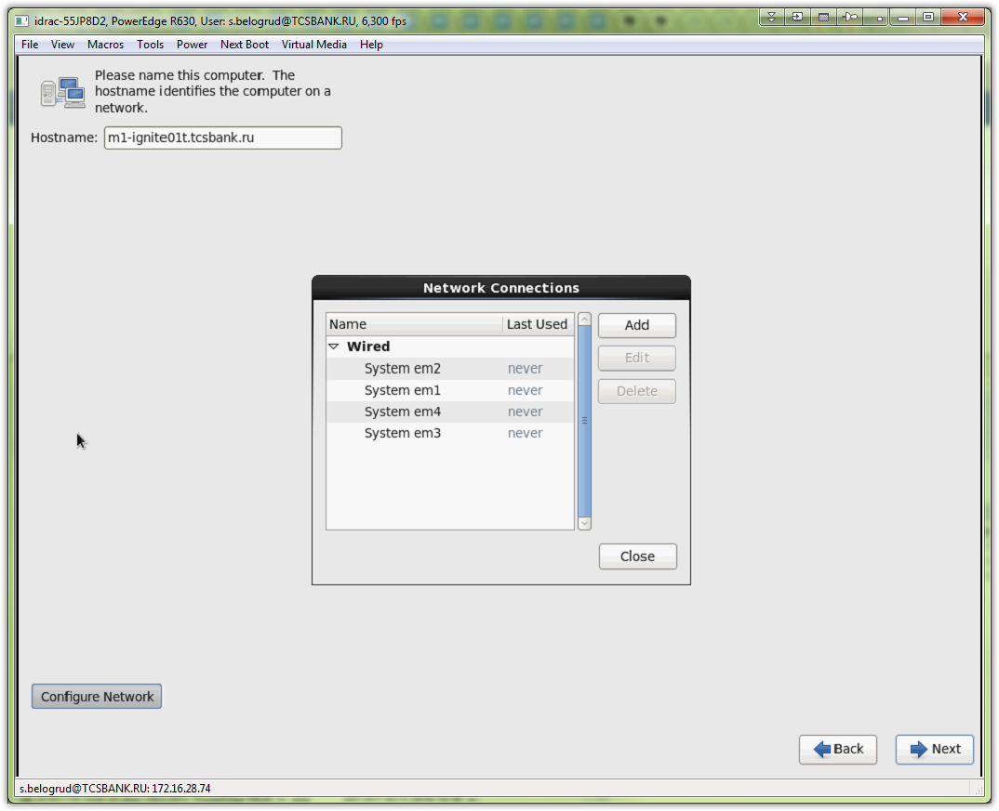

# On this serve were only two network cards connected and had link - em1, em2. I had configure it.
# Other two network cards I became disabled.
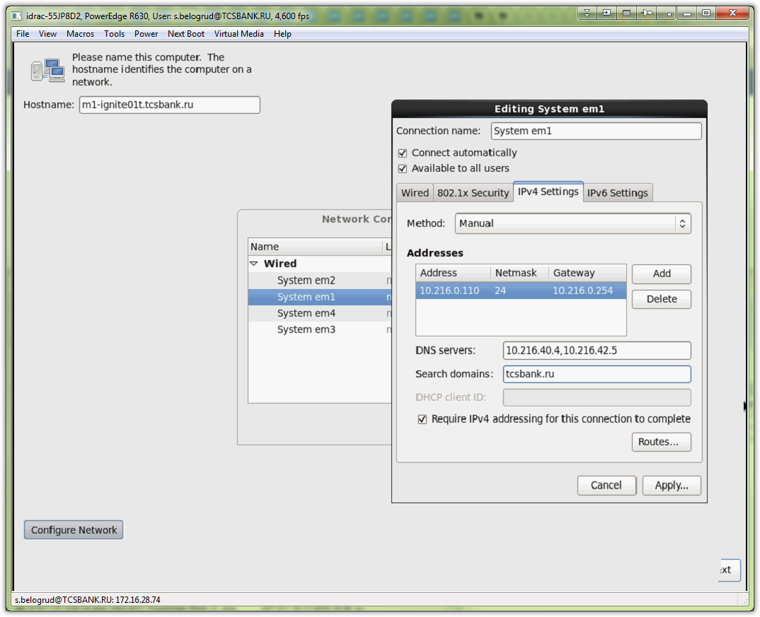

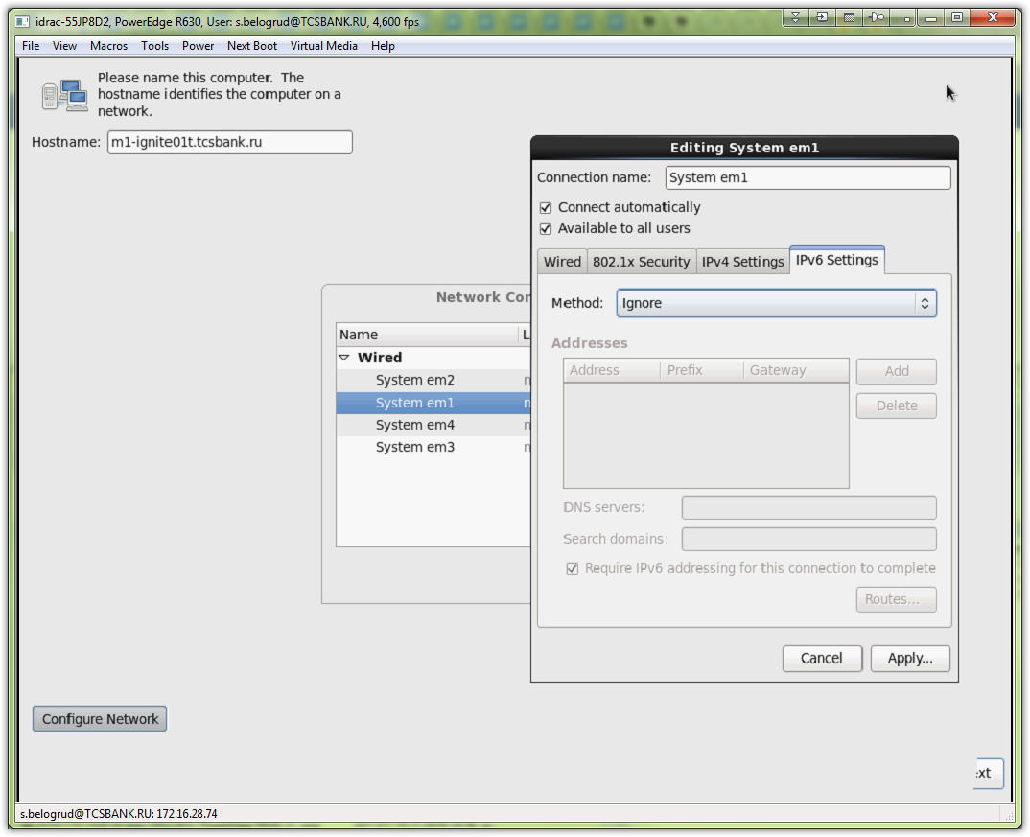
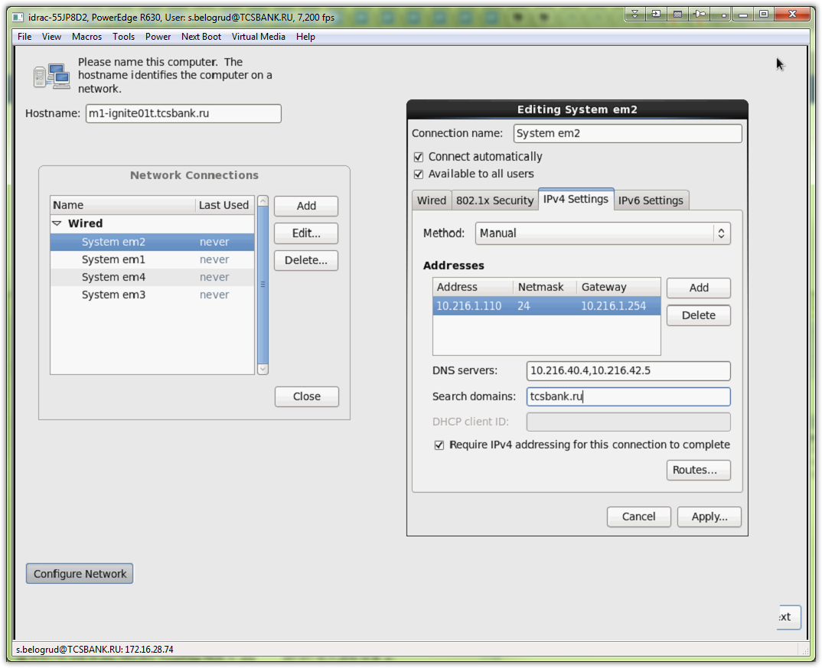
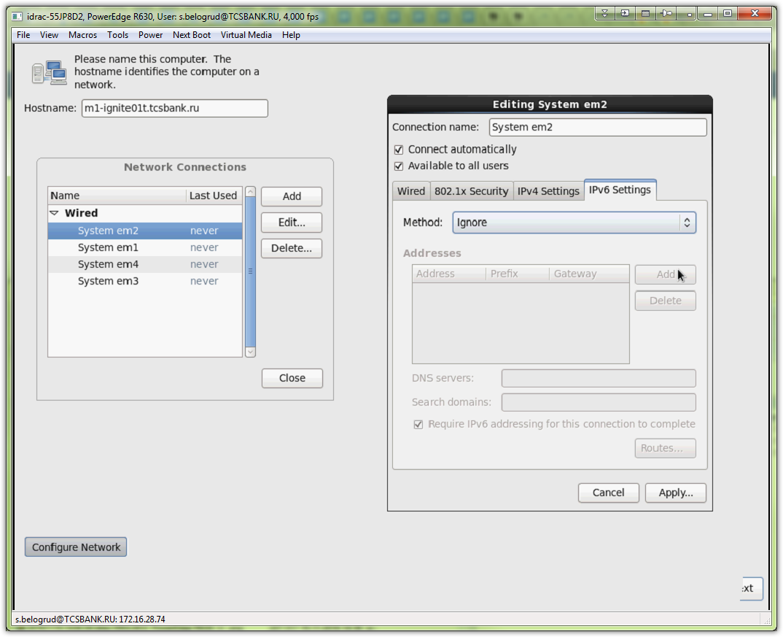

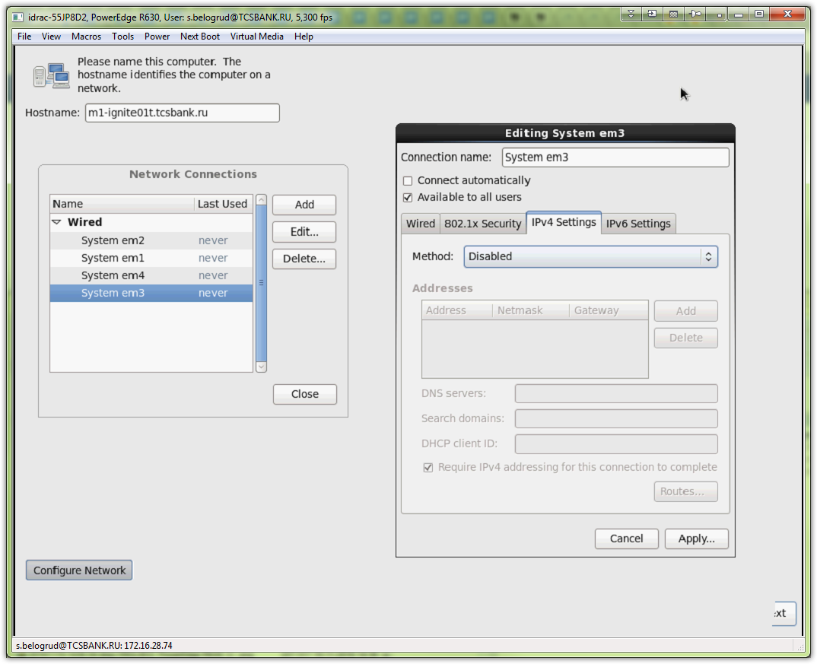

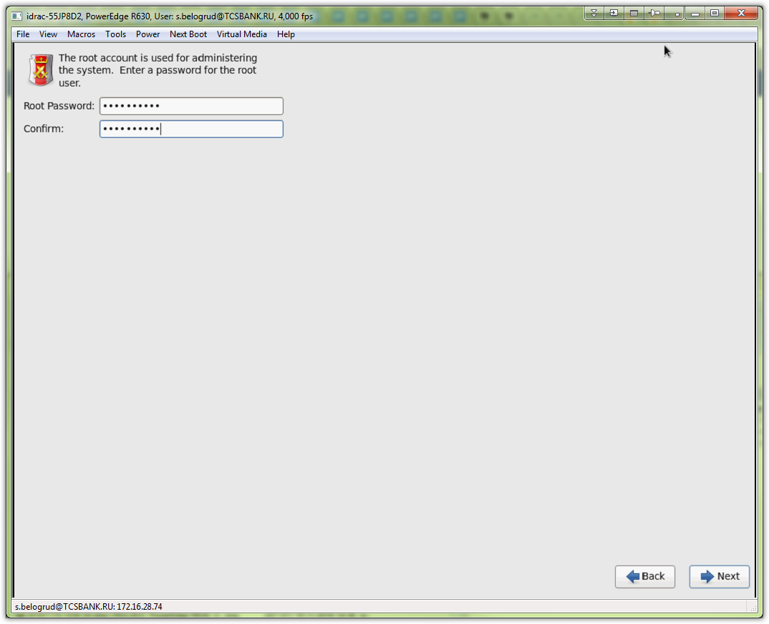

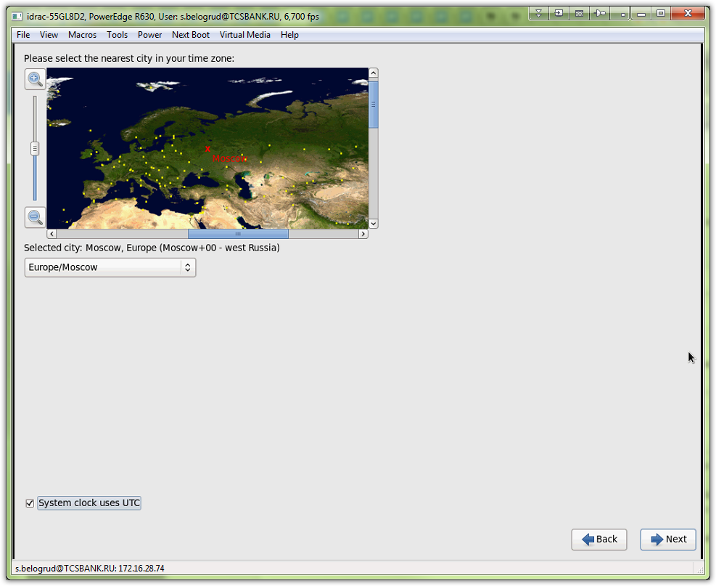

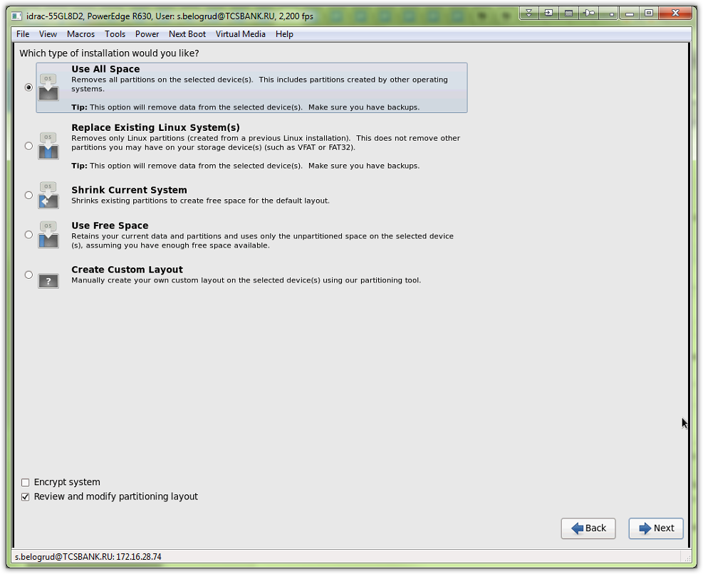

# Below is default partitioning.
# I was delete it and made my own, that was asked by customer of this server.
#
# By the way here is present drive sdc instead sda. This is not important at all. Because after installation will be finished this drive become regular sda drive.
# And everythin will be OK.
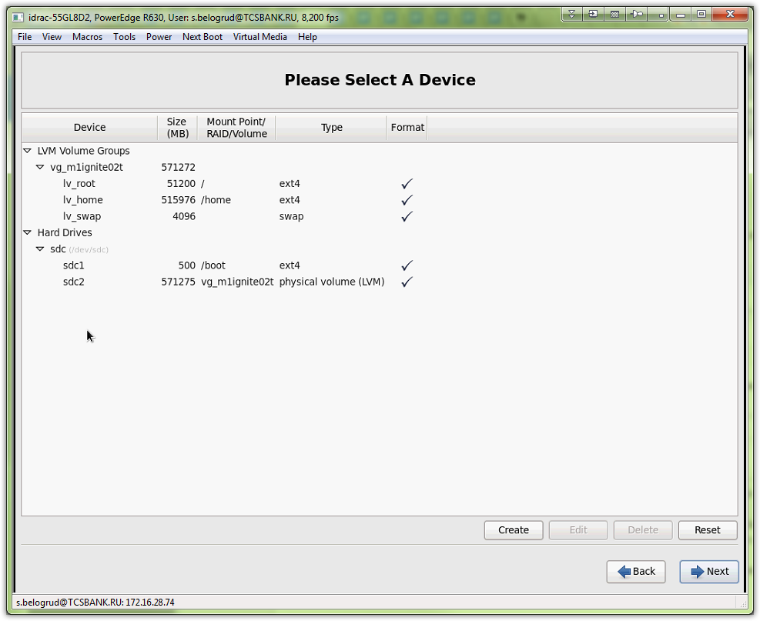

# Here is what I’ve received.
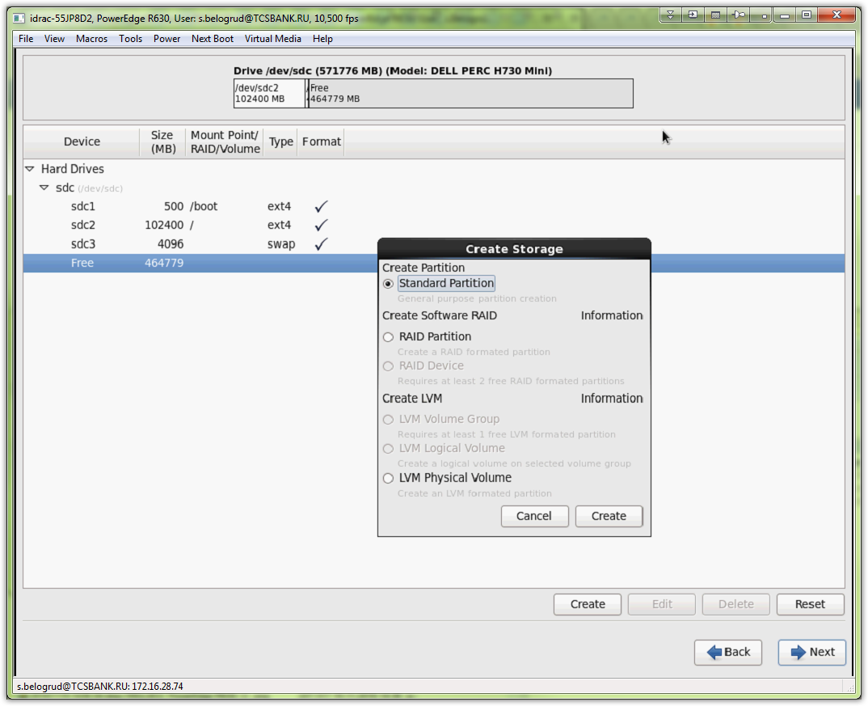
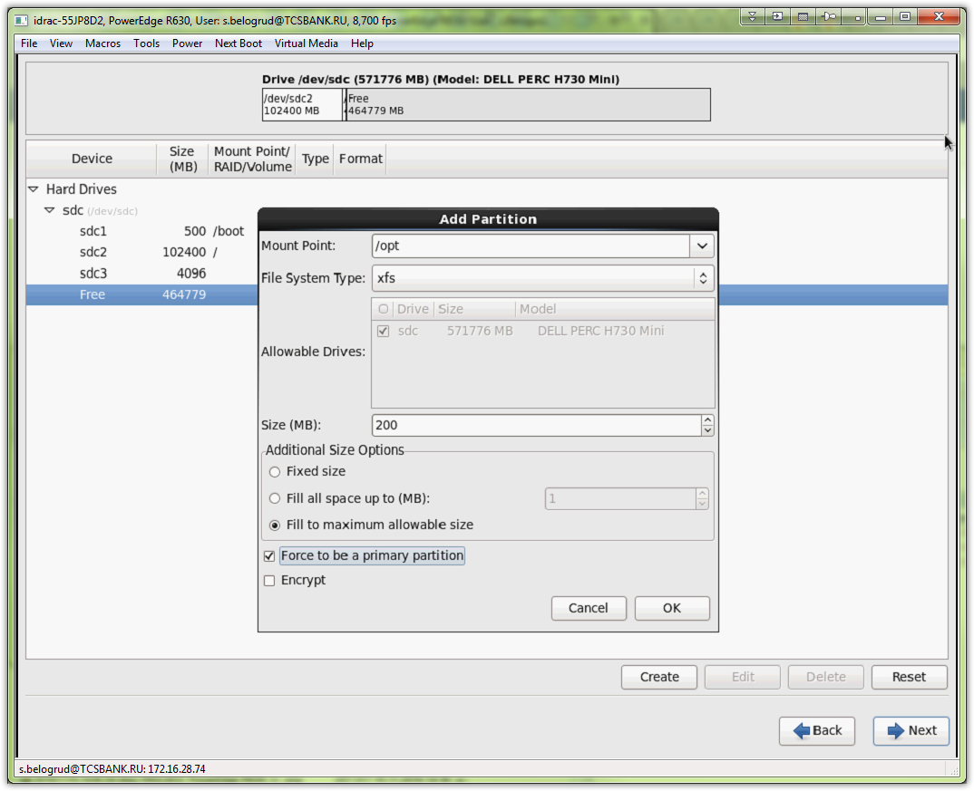
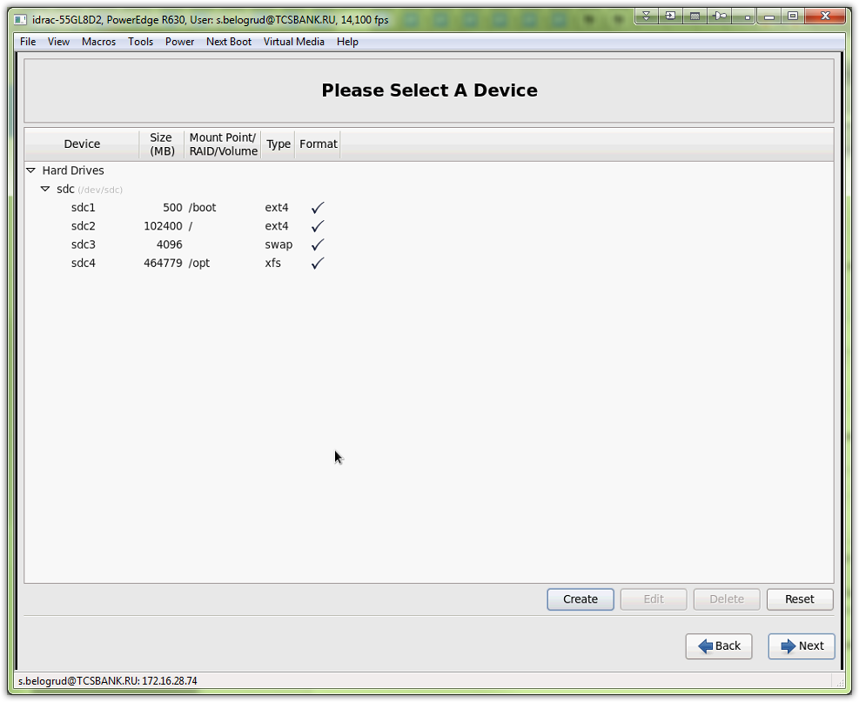
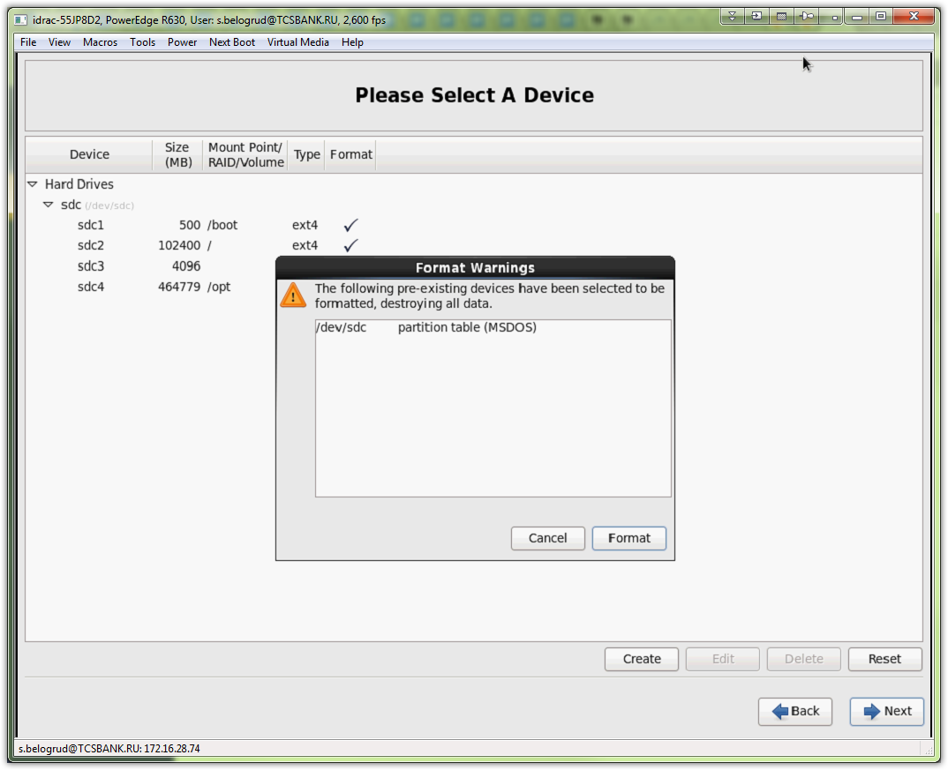
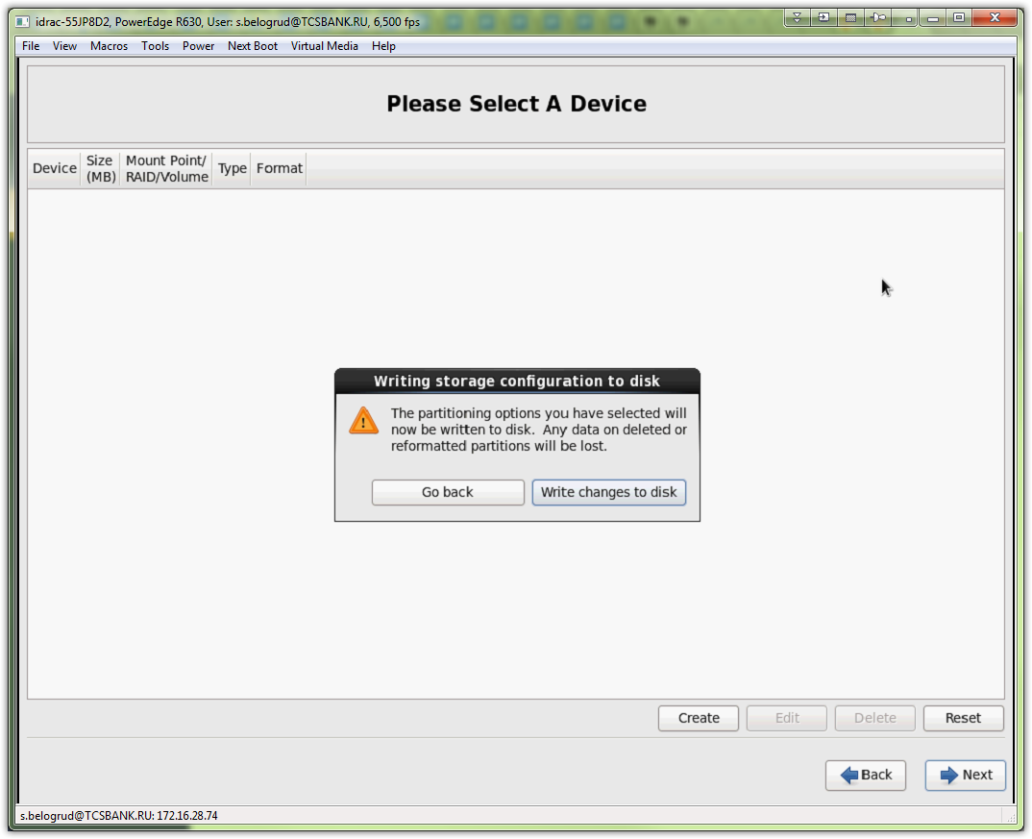
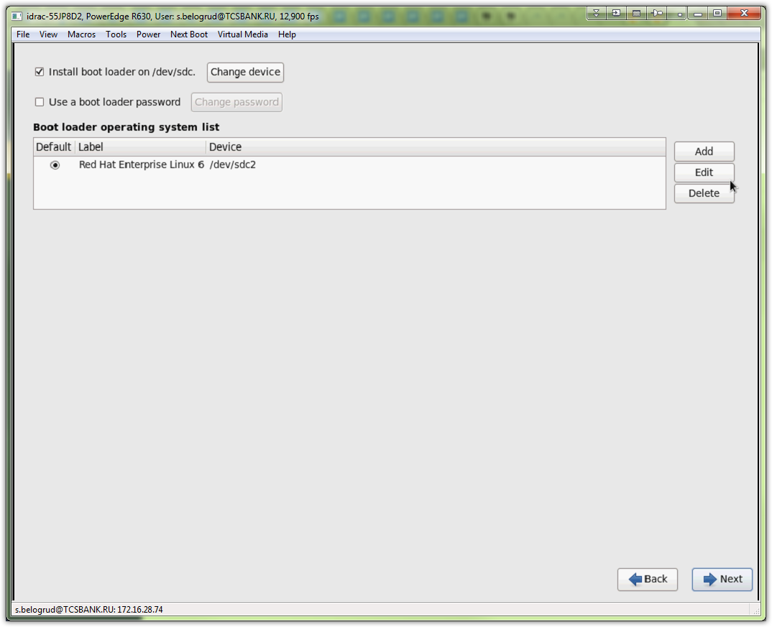

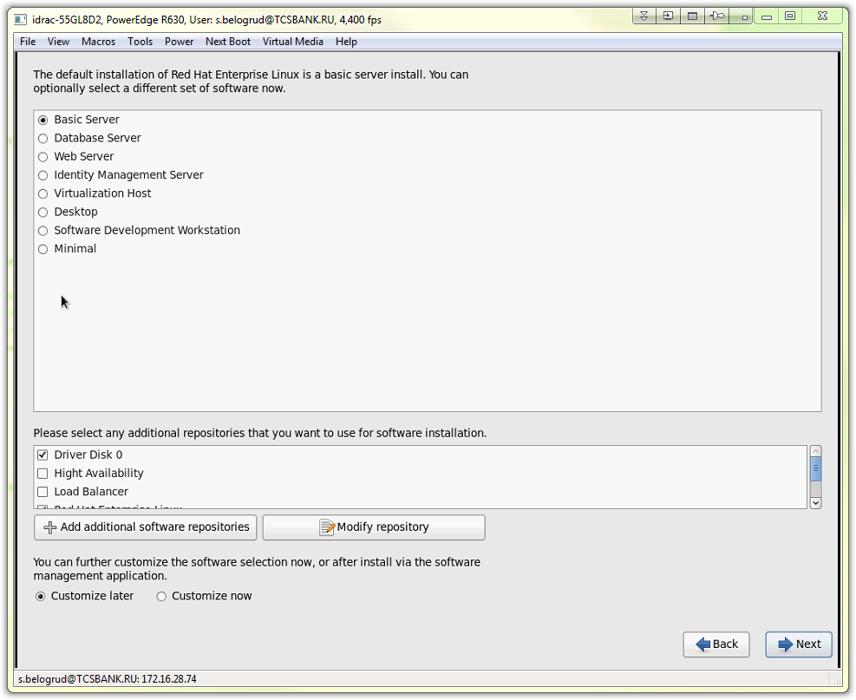

# Here we can see that drivers for kernel, that was given by Lifecycle Controller, are made for rhel 6.7, but we installing rhel 6.6.
# Even so, it work! And I had use it.
